GOVERNMENT ARTS AND SCIENCE COLLEGE
HOSUR-635110.

DEPARTMENT OF COMPUTER SCIENCE

I - M.Sc Computer Science
( I Semester )

PYTHON PROGRAMMING LAB
(23PCSP02)
PRACTICAL RECORD



DEPARTMENT OF COMPUTER SCIENCE
GOVERNMENT ARTS AND SCIENCE COLLEGE
(Affiliated to Periyar University) HOSUR-635110.
NOV - DEC 2025

GOVERNMENT ARTS AND SCIENCE COLLEGE
(Affiliated to Periyar University)
HOSUR-635110.

DEPARTMENT OF COMPUTER SCIENCE

This is to certify that the bonafide Practical record work done by ________________________ and his / her register number _________________ is a Student of Year - M.Sc Computer Science during the academic year 2025-2026.

Staff In-charge Head of the Department

The Practical record note book submitted for the Practical Examination (PYTHON PROGRAMMING LAB – 23PCSP02 ) held on ____________________ at Computer Lab in Government Arts And Science College, Hosur .

Internal Examiner External Examiner

S.NO | DATE | CONTENTS | PAGE NO. | SIGNATURE
1 |  | LIST, DICTIONARIES, AND TUPLES
2 |  | CONDITIONAL BRANCHES
3 |  | LOOPS
4 |  | FUNCTIONS
5 |  | EXCEPTION HANDLING
6 |  | INHERITANCE
7 |  | POLYMORPHISAM
8 |  | FILE OPERATIONS
9 |  | MODULES
10 |  | WEB PAGES USING FORMS

EX.NO: 1(A)  DATE: | TUPLE

AIM:

To write a python program using elementary data items tuples.

ALGORITHM:

STEP 1: Start a program.
STEP 2: Define a tuple x with consonants, vowels digits
and others.
STEP 3: Initialize counters: Ccount, Vcount, Dcount, and
Ocount.
STEP 4: Input a sentence from the user.
STEP 5: For each character in the sentences if, elif, else
are used.
STEP 6: Print the program.
STEP 7: End.

1.A.TUPLE:

PROGRAM:

x=("bcdfghjklmnpqrstwvyz","aeiou","0123456")
ccount=0
vcount=0
dcount=0
ocount=0
str1=input("Enter a sentence..\n")
for i in str1:
if i in x[0]:
ccount=ccount+1
elif i in x[1]:
vcount=vcount+1
elif i in x[2]:
dcount=dcount+1
else:
ocount=ocount+1
print("no of consonents={},vowels={},digits={},others={}".format(ccount,vcount,dcount,ocount))

OUTPUT:

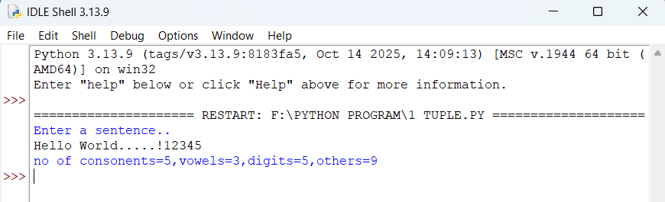

RESULT:

Thus, the program has been executed successfully and output was displayed.
EX.NO: 1(B)  DATE: | LIST

AIM:

To write a python program using elementary data items list.

ALGORITHM:

STEP 1: Start a program.
STEP 2: Create an empty list per[].
STEP 3: Repeat until user chooses to step:
- Input name & age.
- Append [name, age] into the list.
- If user wants to continue.
STEP 4: Print header ( Sno, Name, Age, Status ).
STEP 5: Print the program
STEP 6: End.

1.B.LIST:

PROGRAM:

per=[]
while True:
Name=input("\nEnter a name:")
age=int(input("\nEnter age:"))
per.append([Name,age])
ch=input("continue[y/n]?")
if ch in('n','N'):
break

print(per)
print("\n Sno \tName \t\tAge \tEligible status\n")
l=len(per)
for i in range(len(per)):
if per[i][1]>=18:
print("\n{}\t{}\t\t{}\tEligible\t".format(i+1,per[i][0],per[i][1]))
else:
print("\n{}\t{}\t\t{}\tNot Eligible\t".format(i+1,per[i][0],per[i][1]))

OUTPUT:

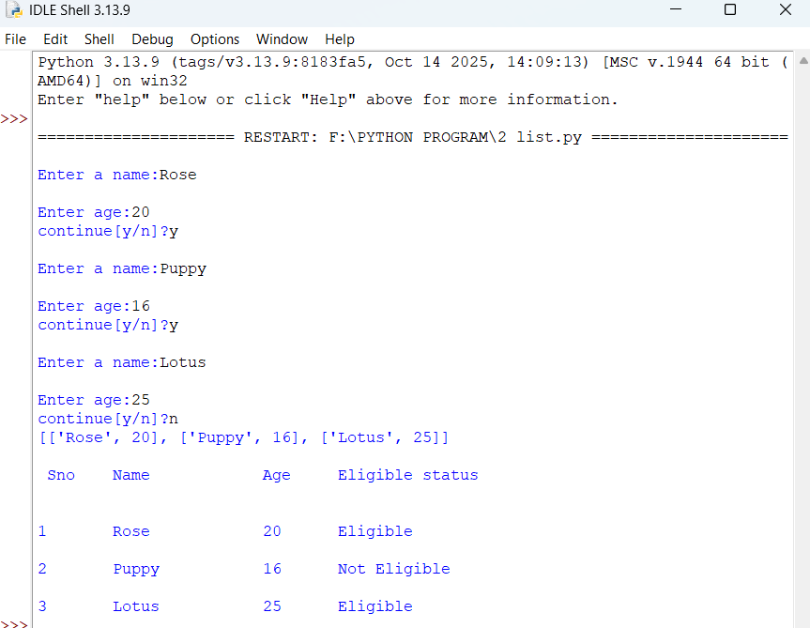

RESULT:

Thus, the program has been executed successfully and output was displayed.
EX.NO: 1(C)  DATE: | DICTIONARIES

AIM:

To write a python program using elementary data items dictionaries.

ALGORITHM:

STEP 1: Start a program.
STEP 2: Create a dictionary with keys: name, age, phone,
gender.
STEP 3: Print name and age.
STEP 4: Recreate dictionary with name and age.
STEP 5: Update, Add, Delete operation are used.
STEP 6: Print dictionary after each operation.
STEP 7: End.

1.B.DICTIONARIES:

PROGRAM:

my_dict={'name':'hemanth','age':21,'phone':6374546440,'gender':'male'}
print(my_dict['name'])
print(my_dict['age'])

my_dict={'name':'hemanth','age':21}
my_dict['age']=23
print(my_dict)

my_dict['Address']='bagalur'
print(my_dict)

del my_dict['name']
print(my_dict)

OUTPUT:

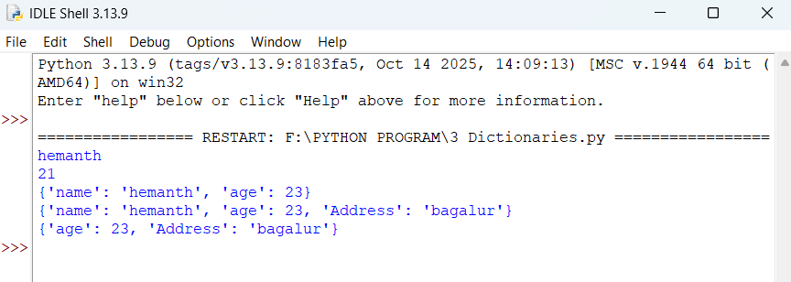

RESULT:

Thus, the program has been executed successfully and output was displayed.
EX.NO: 2  DATE: | CONDITIONAL BRANCHES

AIM:

To write a python program using conditional branches.

ALGORITHM:

STEP 1: Start a program.
STEP 2: Display ‘conditional branches, while loop, and for
loop.
STEP 3: Conditional branches using if, elif, else
conditions, values are ‘Positive, Negative, Zero’.
STEP 4: Print the value of num.
STEP 5: While loop, initialize count, increment, count
by 1.
STEP 6: For loop, using range value and print i.
STEP 7: End.

2. CONDITIONAL BRANCHES:

PROGRAM:

print("conditional branches\n")
num=float(input("Enter the number"))
if num>0:
print("positive number")
elif num<0:
print("Negative number")
else:
print("Number is zero")
print(num)

#loops
print("\nwhile loop")
count=0
while count<10:
print(count)
count=count+1

print("\n for loop")
for i in range(5):
print(i)

OUTPUT:

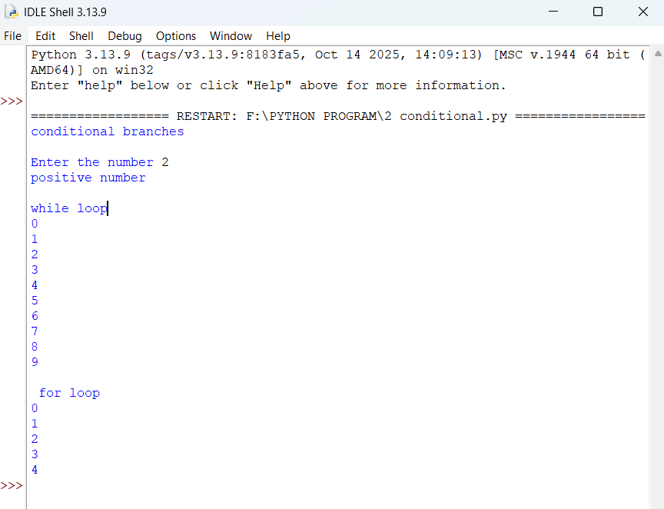

RESULT:

Thus, the program has been executed successfully and output was displayed.
EX.NO: 3  DATE: | LOOPS

AIM:

To write a python program using loops.

ALGORITHM:

STEP 1: Start a program.
STEP 2: Define a class Person with two methods:
getdetails (), printdetails ().
STEP 3: Create an object p of class Person.
STEP 4: Call p.getdetails() to read details from the user.
STEP 5: Call p.printdetails() to display the details.
STEP 6: End.

3. LOOPS:

PROGRAM:

class Person:
def getdetails(self):
self.name=str(input("Enter your name:"))
self.reg=str(input("Enter your Reg no:"))
self.co=str(input("Enter your Course:"))

def printdetails(self):
print("Your name is:",self.name)
print("Your reg.no is:",self.reg)
print("Your course is:",self.co)

p=Person()
p.getdetails()
p.printdetails()

OUTPUT:

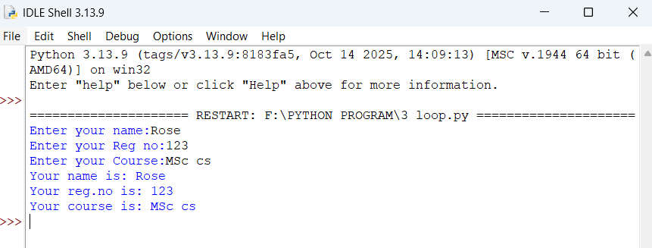

RESULT:

Thus, the program has been executed successfully and output was displayed.
EX.NO: 4  DATE: | FUNCTIONS

AIM:

To write a python program using functions.

ALGORITHM:

STEP 1: Start a program.
STEP 2: Define function: add(), subtract(),
multiply(), divide().
STEP 3: Display user chooses : Add, Subtract, Multiply,
Divede, Exit.
STEP 4: Next using if, elif, else conditions.
STEP 5: Print the program.
STEP 6: End.

4. FUNCTIONS:

PROGRAM:

def add(x,y):
return(x+y)
def substract(x,y):
return(x-y)
def multiply(x,y):
return(x*y)
def divide(x,y):
return(x/y)

loop=1
while loop==1:
print("\n Select Operation \n 1.Add \n 2.Substract \n 3.Multiply \n 4.Divede \n 5.Exit ")

choice=int(input("Enter choice(1/2/3/4/5):"))
if choice==1:
n1=int(input("Enter First number:"))
n2=int(input("Enter Second number:"))
print(n1,"+",n2,"=",add(n1,n2))

elif choice==2:
n1=int(input("Enter First number:"))
n2=int(input("Enter Second number:"))
print(n1,"-",n2,"=",substract(n1,n2))

elif choice==3:
n1=int(input("Enter First number:"))
n2=int(input("Enter Second number:"))
print(n1,"*",n2,"=",multiply(n1,n2))

elif choice==4:
n1=int(input("Enter First number:"))
n2=int(input("Enter Second number:"))
print(n1,"/",n2,"=",divide(n1,n2))

elif choice==5:
print("bye")
break
else:
print("Invalid Operator")

OUTPUT:

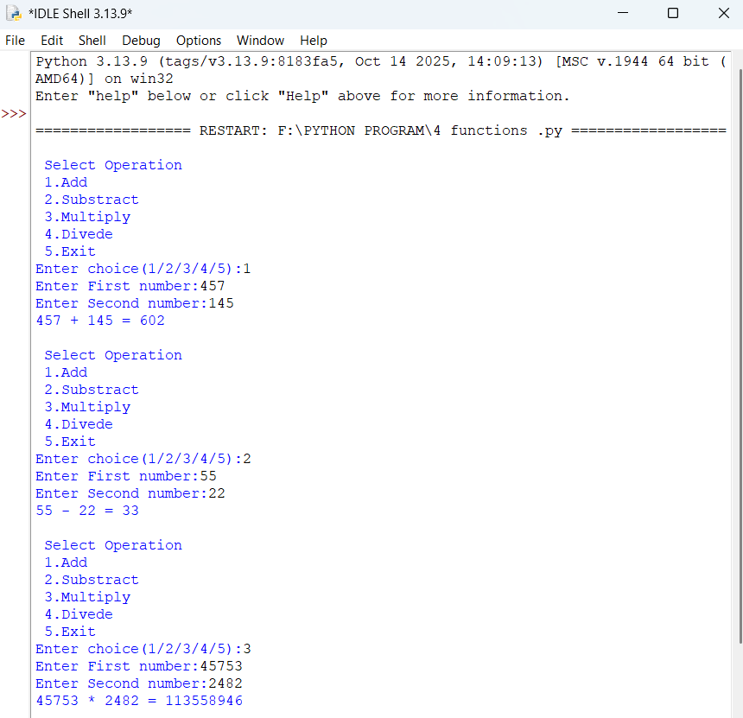

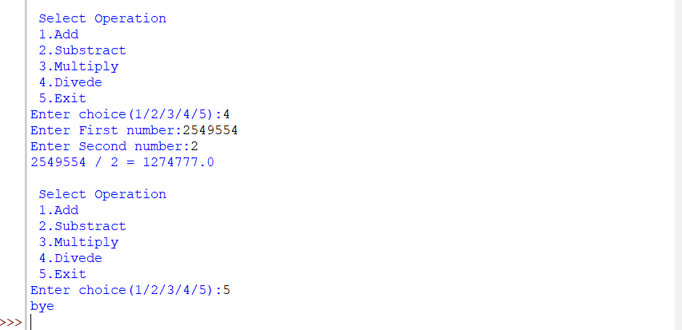

RESULT:

Thus, the program has been executed successfully and output was displayed.
EX.NO: 5  DATE: | EXCEPTION HANDLING

AIM:

To write a python program using exception handling.

ALGORITHM:

STEP 1: Start a program.
STEP 2: Define a base class error.
STEP 3: Define custom exceptions: NagativeValueError,
ValueTooSmallError, ValueTooLargeError.
STEP 4: Set a fixed number.
STEP 5: This program using if, elif, else conditions.
STEP 6: After print the output and display.
STEP 7: End.

5. EXCEPTION HANDLING:

PROGRAM:

class Error(Exception):
pass
class NegativeValueError(Error):
pass
class ValueTooSmallError(Error):
pass
class ValueTooLargeError(Error):
pass

number=11
while True:
try:
num=int(input("Enter a number:"))
if num<0:
raise NegativeValueError
elif num<number:
raise ValueTooSmallError
elif num>number:
raise ValueTooLargeError
else:
print(int(num))
print("correct value entered")
break

except NegativeValueError:
print("This is a nagetive value,try again")
print("")

except ValueTooSmallError:
print("This value is too small,try again")
print("")

except ValueTooLargeError:
print("This value is too large,try again")
print("")

except ValueError:
print("Please enter an integer")
print("")

OUTPUT:

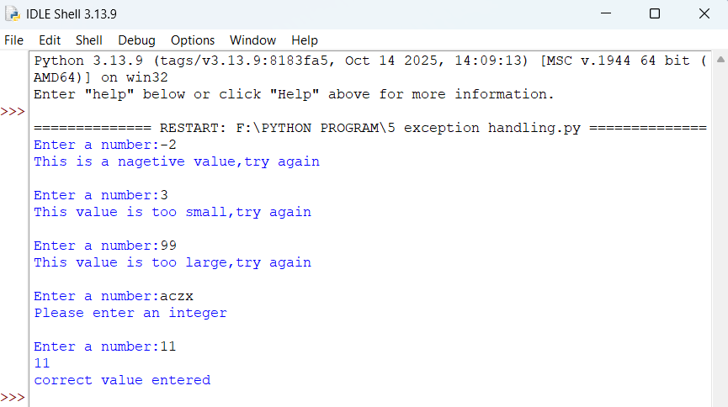

RESULT

Thus, the program has been executed successfully and output was displayed.
EX.NO: 6  DATE: | INHERITANCE

AIM:

To write a python program using inheritance.

ALGORITHM:

STEP 1: Start a program.
STEP 2: Define a class college with two methods:
getdetails(), printdetails().
STEP 3: Define a class HOD, HODdetails, HODprint (inherits
from college).
STEP 4: Define a class Lectures, ledetails, leprint
(inherits from HOD).
STEP 5: Create two lecturer objects c and d.
STEP 6: Call getname(), HODdetails(), ledetails(), for
objects c.
STEP 7: Call ledetails() for object d.
STEP 8: Print the program.
STEP 9: End.

6. INHERITANCE:

PROGRAM:

class college:
def getname(self):
self.name=str(input("Enter the college name:"))
def printname(self):
print("\t",self.name)

class HOD(college):
def HODdetails(self):
self.name=str(input("Enter your HOD name:"))
self.no=int(input("Enter your ID:"))
def HODprint(self):
print("Your HOD name:",self.name)
print("Your HOD ID no:",self.no)

class Lecturers(HOD):
def ledetails(self):
self.ln=str(input("Enter your staff name:"))
self.lno=int(input("Enter your staff ID:"))
def leprint(self):
print("Your Lecturer name:",self.ln)
print("Your Lecturer ID no:",self.lno)

c=Lecturers()
d=Lecturers()
c.getname()
c.HODdetails()
c.ledetails()
d.ledetails()

print("\n")
print("************************************")
c.printname()
print("************************************")
c.HODprint()
print("************************************")
c.leprint()
d.leprint()
print("************************************")

OUTPUT:

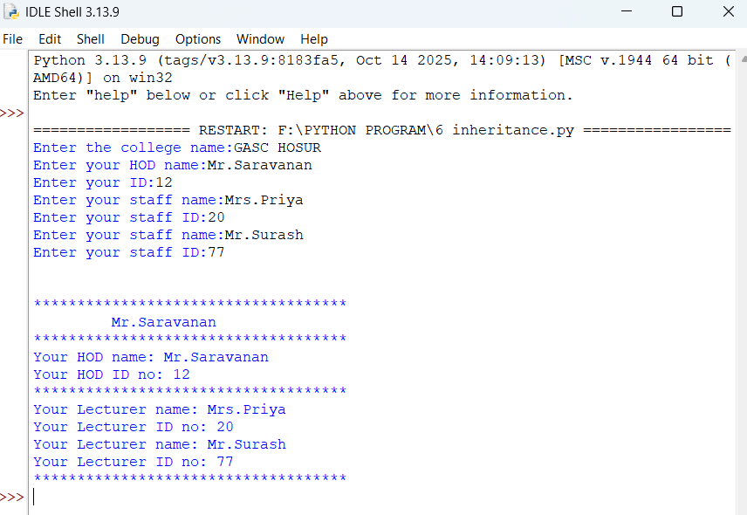

RESULT

Thus, the program has been executed successfully and output was displayed.
EX.NO: 7  DATE: | POLYMORPHISM

AIM:

To write a python program using polymorphism.

ALGORITHM:

STEP 1: Start a program.
STEP 2: Define a class company: __init__(), display().
STEP 3: Define a class regular employee (inherits from
company) and getdata(), display().
STEP 4: Define a class workers (inherit from
regular_employee) and geydata(), display().
STEP 5: Create objects w of class workers.
STEP 6: Call w.getdata() input company regular employee
and workers details.
STEP 7: Call w.display() output company, regular employee
and workers details.
STEP 8: End.

7. POLYMORPHISM:

PROGRAM:

class company:
def __init__(self):
self.na=str(input("Enter your company name:"))
def display(self):
print("*********************")
print("\t",self.na)
print("*********************")

class regularemployee(company):
def getdata(self):
print("Enter the regular employee details")
self.empname=str(input("Enter your name:"))
self.empno=int(input("Enter your no:"))
self.sal=input("Enter your sal:")
def display(self):
super().display()
print("*************************")
print("\t Regular Employee Details")
print("*************************")
print("Employee Name:",self.empname)
print("Employee No:",self.empno)
print("Employee sal:",self.sal)

class workers(regularemployee):
def getdata(self):
super().getdata()
print("Enter the Worker details")
self.wname=str(input("Enter your name:"))
self.wno=int(input("Enter your id no:"))
self.wsal=int(input("Enter your sal:"))
def display(self):
super().display()
print("******************")
print("\t Worker Details")
print("******************")
print("Employee Name:",self.wname)
print("Employee No:",self.wno)
print("Employee sal:",self.wsal)

w=workers()
w.getdata()
w.display()

OUTPUT:

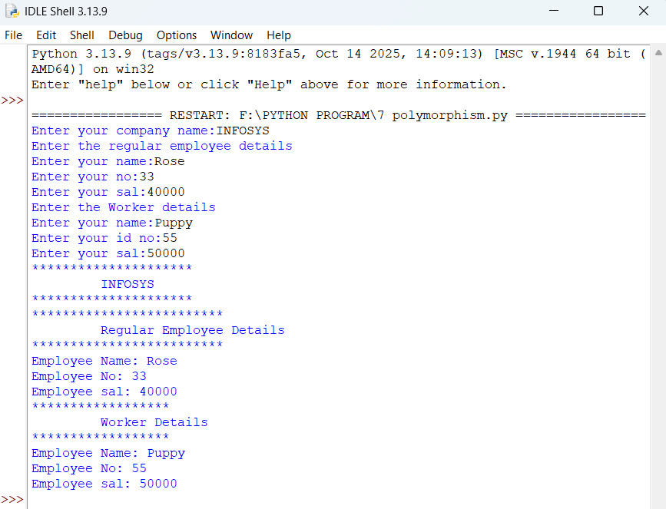

RESULT

Thus, the program has been executed successfully and output was displayed.
EX.NO: 8  DATE: | FILE OPERATIONS

AIM:

To write a python program using file operations.

ALGORITHM:

STEP 1: Start a program.
STEP 2: Input the name of first, second folder and create
it.
STEP 3: Input file name for first folder and write a
sentence.
STEP 4: Open the file again, move to start, read till end
and store in sentence.
STEP 5: Again repeat the process in the second folder.
STEP 6: Input a third file name merging create and write
both sentences into it.
STEP 7: Print the program.
STEP 8: End.

7. POLYMORPHISM:

PROGRAM:

import os
folder1=input("Enter the name of 1st folder:")
os.mkdir(folder1)
folder2=input("Enter the name of 2nd folder:")
os.mkdir(folder2)
os.chdir(folder1)
file1=input("Enter the name of file in 1st folder:")
f=open(file1,'w')
sentence=input("Enter the sentence of input:")
f.write(sentence)
f.close()
start=int(input("Enter the starting point:"))
end=int(input("Enter the ending point:"))
f=open(file1,'a+')
f.seek(start)
sentence2=f.read(end)
f.close()
os.chdir('..')
os.chdir(folder2)
file2=input("Enter the name of file in 2nd folder:")
f=open(file2,'w')
f.write(sentence2)
f.close()
file3=input("Enter the file name to merge:")
f=open(file3,'w')
f.write(sentence)
f.write(sentence2)
f.close()
os.chdir('..')
os.chdir(folder2)
os.rename(file2,'2nd.txt')
os.chdir('..')
os.chdir(folder1)

OUTPUT:

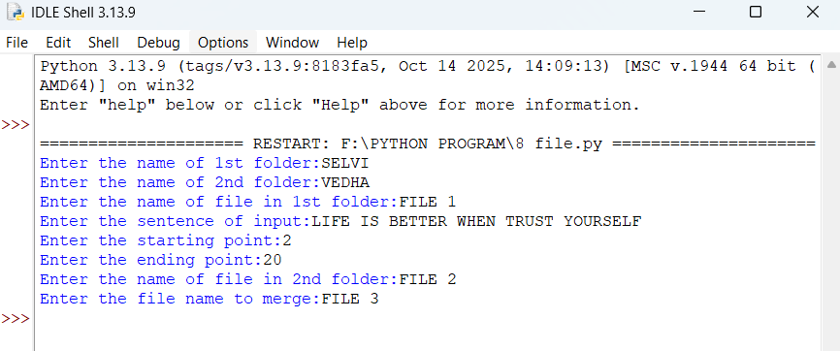

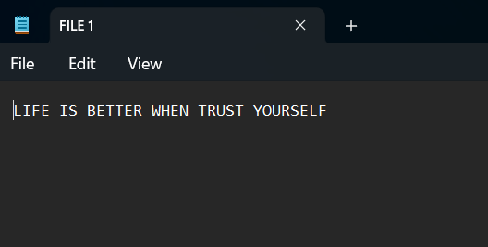

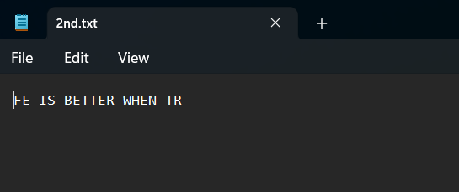

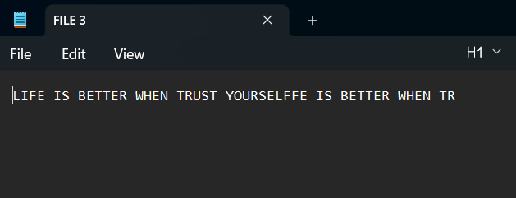

RESULT

Thus, the program has been executed successfully and output was displayed.
EX.NO: 9  DATE: | MODULES

AIM:

To write a python program using modules.

ALGORITHM:

STEP 1: Start a program.
STEP 2: Import the module ‘modules’.
STEP 3: Prompt the user to: Enter the Employee ID, Name,
Phone no, Basic pay.
STEP 4: Call the display() function from ‘modules’ with
the input value.
STEP 5: In the display() function: Print Employee details.
STEP 6: And calculate them and print the salary
components.
STEP 7: End.

9. MODULES:

PROGRAM:

//Modules.py

def display(a,b,c,bs):

print("Employee Details")
print("--------------")
print("Employee ID=",a)
print("Employee Name=",b)
print("Employee phone number=",c)
print("salary details")
print("-----")

pf=bs/100*8
da=bs/100*15
hra=bs/100*10
ns=bs+da+hra
gs=bs-pf

print("The Basic Pay is=",bs)
print("The PF is=",pf)
print("The DA is=",da)
print("The HRA is=",hra)
print("The ns is=",ns)
print("The GS is=",gs)

//9.modules.py

import modules
a=int(input("Enter the Employee ID:"))
b=input("Enter the Employee Name:")
c=int(input("Enter the Employe Phone number:"))
bs=int(input("Enter the Employee Basic Pay:"))
modules.display(a,b,c,bs)
OUTPUT:

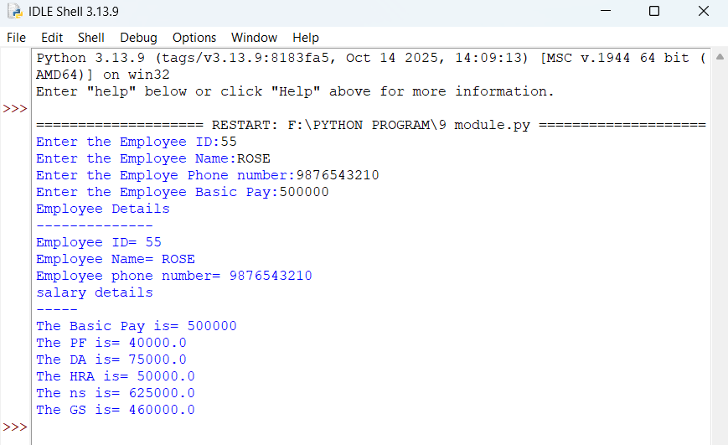

RESULT

Thus, the program has been executed successfully and output was displayed.
EX.NO: 10  DATE: | WEB PAGES USING FORMS

AIM:

To write a python program for creating dynamic and interactive web pages using forms..

ALGORITHM:

STEP 1: Start a program.
STEP 2: Define the HTML content.
STEP 3: Define the str ToFile (text, filename).
STEP 4: Define browseLocal(webpageText) save the HTML
content to a file.
STEP 5: In main(): Call browseLocal(contents).
STEP 6: Web1.html display:
- A read background color
- A quotes (friendship)
- An image
STEP 7: End.

10. WEB PAGES USING FORMS:

PROGRAM:

contents='''<!DOCTYPE html>
<html>
<head>
</head>
<body bgcolor="pink">
<form action="web1.html">
<center><input type="submit"value="click me"></center>
</form>
</body>
</html>'''

def main():
browseLocal(contents)

def strToFile(text,filename):
output=open(filename,'w')
output.write(text)
output.close()

def browseLocal(webpageText,filename='tempBrowseLocal.html'):
import webbrowser,os.path
strToFile (webpageText,filename)
webbrowser.open("file://"+os.path.abspath(filename))

main()

//web1.html

<html>
<head>
<title>HELLO</title>
</head>
<body bgcolor=grey>
<p><center><font color=black><h>!!!!. The Greatest gift of life is Friendship, and have received it !!!!.</b></font></p>
<center><img src="C:/Users/Selvi-Seladurai/Pictures/Screenshot_20221115_152827[1].jpg"/>
</body>
</html>
OUTPUT:

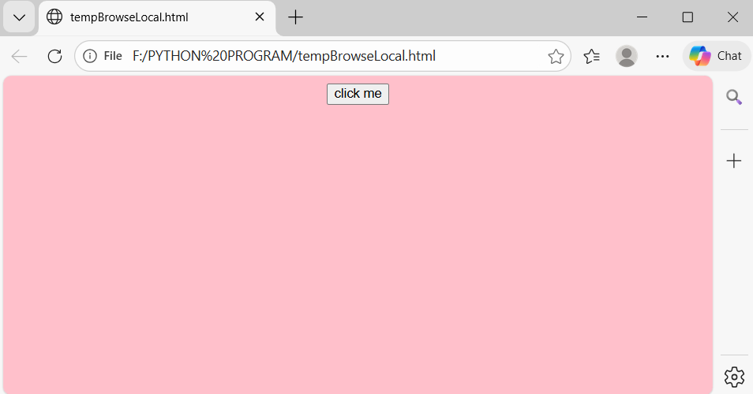



RESULT

Thus, the program has been executed successfully and output was displayed.

